Example – This has only been done up for 2021 Season.
See example below.
White Card Home Team – Left hand Side
Blue Card Away/ Visitor Team – Right Hand side
This isn’t a requirement, just a thought for Managers who would prefer not to write on the scorecard each week. Cut names and paste so that the names line up with each line on the scorecard.

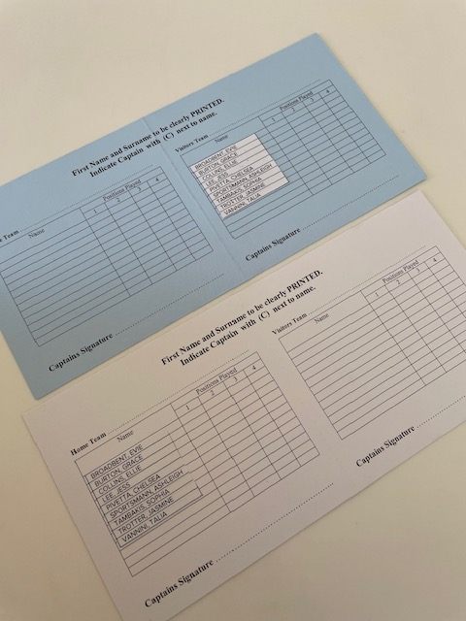

SURNAME, FIRST NAME | SURNAME, FIRST NAME | SURNAME, FIRST NAME | SURNAME, FIRST NAME
SURNAME, FIRST NAME | SURNAME, FIRST NAME | SURNAME, FIRST NAME | SURNAME, FIRST NAME
SURNAME, FIRST NAME | SURNAME, FIRST NAME | SURNAME, FIRST NAME | SURNAME, FIRST NAME
SURNAME, FIRST NAME | SURNAME, FIRST NAME | SURNAME, FIRST NAME | SURNAME, FIRST NAME
SURNAME, FIRST NAME | SURNAME, FIRST NAME | SURNAME, FIRST NAME | SURNAME, FIRST NAME
SURNAME, FIRST NAME | SURNAME, FIRST NAME | SURNAME, FIRST NAME | SURNAME, FIRST NAME
SURNAME, FIRST NAME | SURNAME, FIRST NAME | SURNAME, FIRST NAME | SURNAME, FIRST NAME
SURNAME, FIRST NAME | SURNAME, FIRST NAME | SURNAME, FIRST NAME | SURNAME, FIRST NAME
SURNAME, FIRST NAME | SURNAME, FIRST NAME | SURNAME, FIRST NAME | SURNAME, FIRST NAME

SURNAME, FIRST NAME | SURNAME, FIRST NAME | SURNAME, FIRST NAME | SURNAME, FIRST NAME
SURNAME, FIRST NAME | SURNAME, FIRST NAME | SURNAME, FIRST NAME | SURNAME, FIRST NAME
SURNAME, FIRST NAME | SURNAME, FIRST NAME | SURNAME, FIRST NAME | SURNAME, FIRST NAME
SURNAME, FIRST NAME | SURNAME, FIRST NAME | SURNAME, FIRST NAME | SURNAME, FIRST NAME
SURNAME, FIRST NAME | SURNAME, FIRST NAME | SURNAME, FIRST NAME | SURNAME, FIRST NAME
SURNAME, FIRST NAME | SURNAME, FIRST NAME | SURNAME, FIRST NAME | SURNAME, FIRST NAME
SURNAME, FIRST NAME | SURNAME, FIRST NAME | SURNAME, FIRST NAME | SURNAME, FIRST NAME
SURNAME, FIRST NAME | SURNAME, FIRST NAME | SURNAME, FIRST NAME | SURNAME, FIRST NAME
SURNAME, FIRST NAME | SURNAME, FIRST NAME | SURNAME, FIRST NAME | SURNAME, FIRST NAME

SURNAME, FIRST NAME | SURNAME, FIRST NAME | SURNAME, FIRST NAME | SURNAME, FIRST NAME
SURNAME, FIRST NAME | SURNAME, FIRST NAME | SURNAME, FIRST NAME | SURNAME, FIRST NAME
SURNAME, FIRST NAME | SURNAME, FIRST NAME | SURNAME, FIRST NAME | SURNAME, FIRST NAME
SURNAME, FIRST NAME | SURNAME, FIRST NAME | SURNAME, FIRST NAME | SURNAME, FIRST NAME
SURNAME, FIRST NAME | SURNAME, FIRST NAME | SURNAME, FIRST NAME | SURNAME, FIRST NAME
SURNAME, FIRST NAME | SURNAME, FIRST NAME | SURNAME, FIRST NAME | SURNAME, FIRST NAME
SURNAME, FIRST NAME | SURNAME, FIRST NAME | SURNAME, FIRST NAME | SURNAME, FIRST NAME
SURNAME, FIRST NAME | SURNAME, FIRST NAME | SURNAME, FIRST NAME | SURNAME, FIRST NAME
SURNAME, FIRST NAME | SURNAME, FIRST NAME | SURNAME, FIRST NAME | SURNAME, FIRST NAME

SURNAME, FIRST NAME | SURNAME, FIRST NAME | SURNAME, FIRST NAME | SURNAME, FIRST NAME
SURNAME, FIRST NAME | SURNAME, FIRST NAME | SURNAME, FIRST NAME | SURNAME, FIRST NAME
SURNAME, FIRST NAME | SURNAME, FIRST NAME | SURNAME, FIRST NAME | SURNAME, FIRST NAME
SURNAME, FIRST NAME | SURNAME, FIRST NAME | SURNAME, FIRST NAME | SURNAME, FIRST NAME
SURNAME, FIRST NAME | SURNAME, FIRST NAME | SURNAME, FIRST NAME | SURNAME, FIRST NAME
SURNAME, FIRST NAME | SURNAME, FIRST NAME | SURNAME, FIRST NAME | SURNAME, FIRST NAME
SURNAME, FIRST NAME | SURNAME, FIRST NAME | SURNAME, FIRST NAME | SURNAME, FIRST NAME
SURNAME, FIRST NAME | SURNAME, FIRST NAME | SURNAME, FIRST NAME | SURNAME, FIRST NAME
SURNAME, FIRST NAME | SURNAME, FIRST NAME | SURNAME, FIRST NAME | SURNAME, FIRST NAME

SURNAME, FIRST NAME | SURNAME, FIRST NAME | SURNAME, FIRST NAME | SURNAME, FIRST NAME
SURNAME, FIRST NAME | SURNAME, FIRST NAME | SURNAME, FIRST NAME | SURNAME, FIRST NAME
SURNAME, FIRST NAME | SURNAME, FIRST NAME | SURNAME, FIRST NAME | SURNAME, FIRST NAME
SURNAME, FIRST NAME | SURNAME, FIRST NAME | SURNAME, FIRST NAME | SURNAME, FIRST NAME
SURNAME, FIRST NAME | SURNAME, FIRST NAME | SURNAME, FIRST NAME | SURNAME, FIRST NAME
SURNAME, FIRST NAME | SURNAME, FIRST NAME | SURNAME, FIRST NAME | SURNAME, FIRST NAME
SURNAME, FIRST NAME | SURNAME, FIRST NAME | SURNAME, FIRST NAME | SURNAME, FIRST NAME
SURNAME, FIRST NAME | SURNAME, FIRST NAME | SURNAME, FIRST NAME | SURNAME, FIRST NAME
SURNAME, FIRST NAME | SURNAME, FIRST NAME | SURNAME, FIRST NAME | SURNAME, FIRST NAME

SURNAME, FIRST NAME | SURNAME, FIRST NAME | SURNAME, FIRST NAME | SURNAME, FIRST NAME
SURNAME, FIRST NAME | SURNAME, FIRST NAME | SURNAME, FIRST NAME | SURNAME, FIRST NAME
SURNAME, FIRST NAME | SURNAME, FIRST NAME | SURNAME, FIRST NAME | SURNAME, FIRST NAME
SURNAME, FIRST NAME | SURNAME, FIRST NAME | SURNAME, FIRST NAME | SURNAME, FIRST NAME
SURNAME, FIRST NAME | SURNAME, FIRST NAME | SURNAME, FIRST NAME | SURNAME, FIRST NAME
SURNAME, FIRST NAME | SURNAME, FIRST NAME | SURNAME, FIRST NAME | SURNAME, FIRST NAME
SURNAME, FIRST NAME | SURNAME, FIRST NAME | SURNAME, FIRST NAME | SURNAME, FIRST NAME
SURNAME, FIRST NAME | SURNAME, FIRST NAME | SURNAME, FIRST NAME | SURNAME, FIRST NAME
SURNAME, FIRST NAME | SURNAME, FIRST NAME | SURNAME, FIRST NAME | SURNAME, FIRST NAME

SURNAME, FIRST NAME | SURNAME, FIRST NAME | SURNAME, FIRST NAME | SURNAME, FIRST NAME
SURNAME, FIRST NAME | SURNAME, FIRST NAME | SURNAME, FIRST NAME | SURNAME, FIRST NAME
SURNAME, FIRST NAME | SURNAME, FIRST NAME | SURNAME, FIRST NAME | SURNAME, FIRST NAME
SURNAME, FIRST NAME | SURNAME, FIRST NAME | SURNAME, FIRST NAME | SURNAME, FIRST NAME
SURNAME, FIRST NAME | SURNAME, FIRST NAME | SURNAME, FIRST NAME | SURNAME, FIRST NAME
SURNAME, FIRST NAME | SURNAME, FIRST NAME | SURNAME, FIRST NAME | SURNAME, FIRST NAME
SURNAME, FIRST NAME | SURNAME, FIRST NAME | SURNAME, FIRST NAME | SURNAME, FIRST NAME
SURNAME, FIRST NAME | SURNAME, FIRST NAME | SURNAME, FIRST NAME | SURNAME, FIRST NAME
SURNAME, FIRST NAME | SURNAME, FIRST NAME | SURNAME, FIRST NAME | SURNAME, FIRST NAME

